Jason Loo

Exercise 11

**Read:**

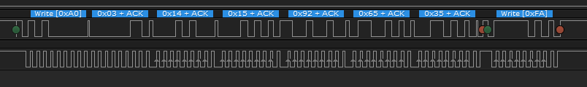

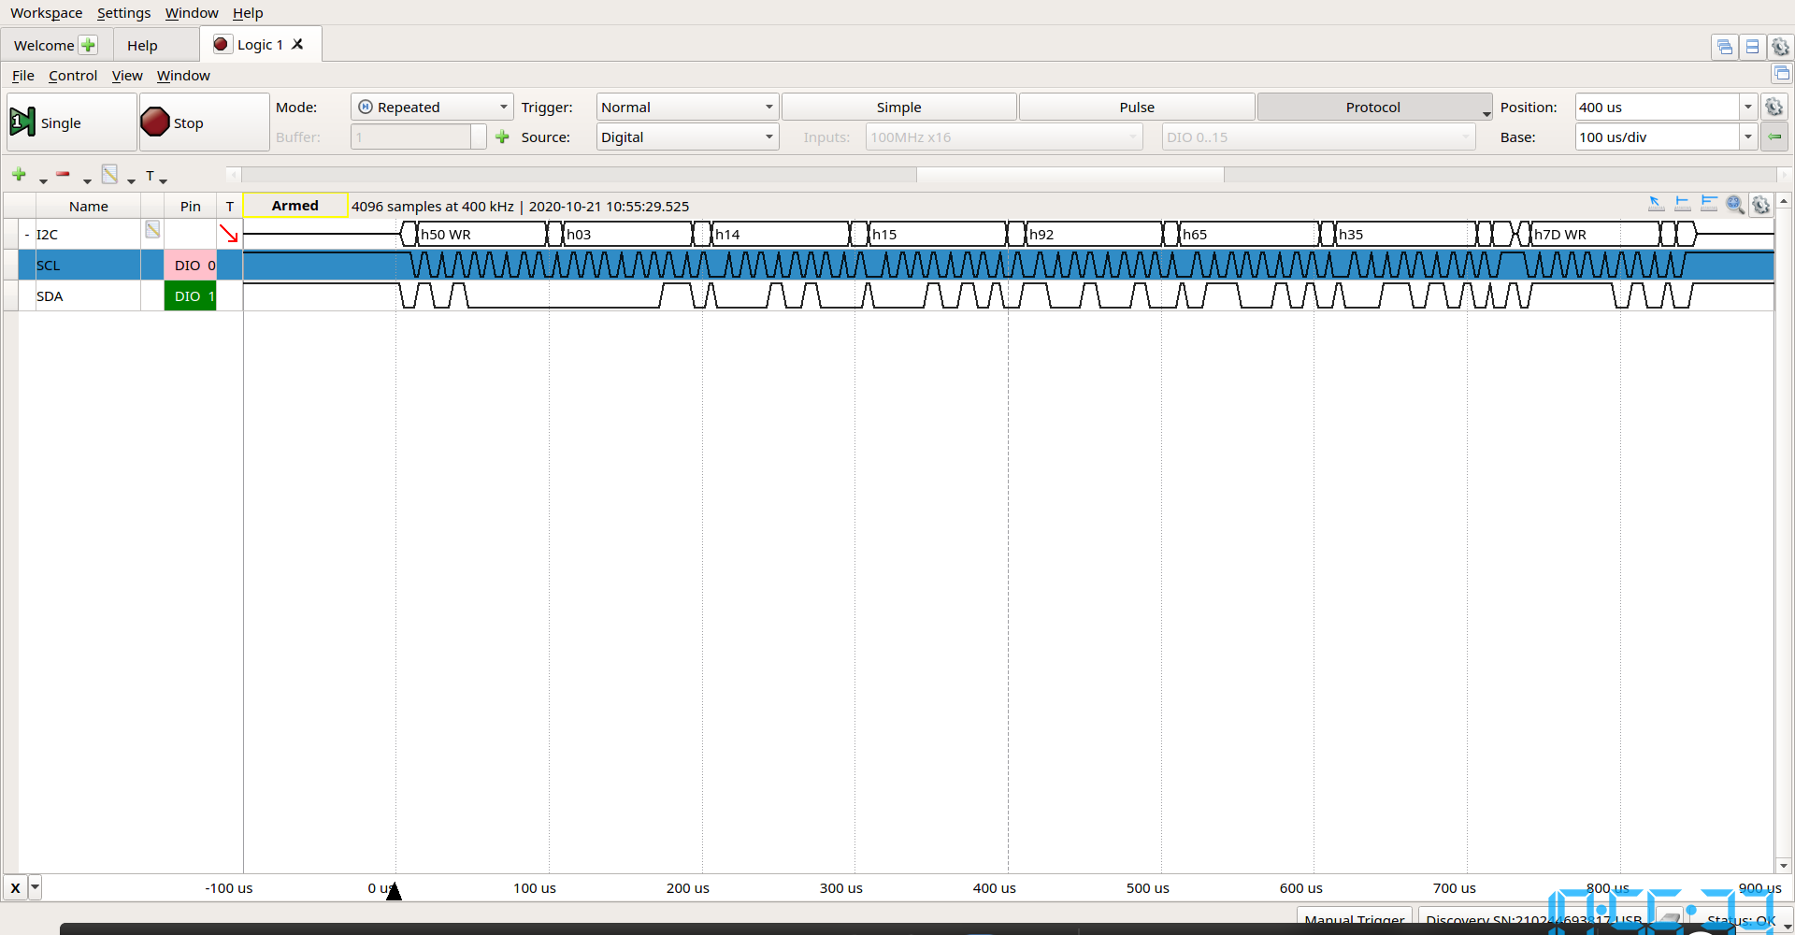

**Write:**

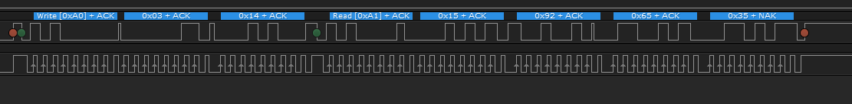

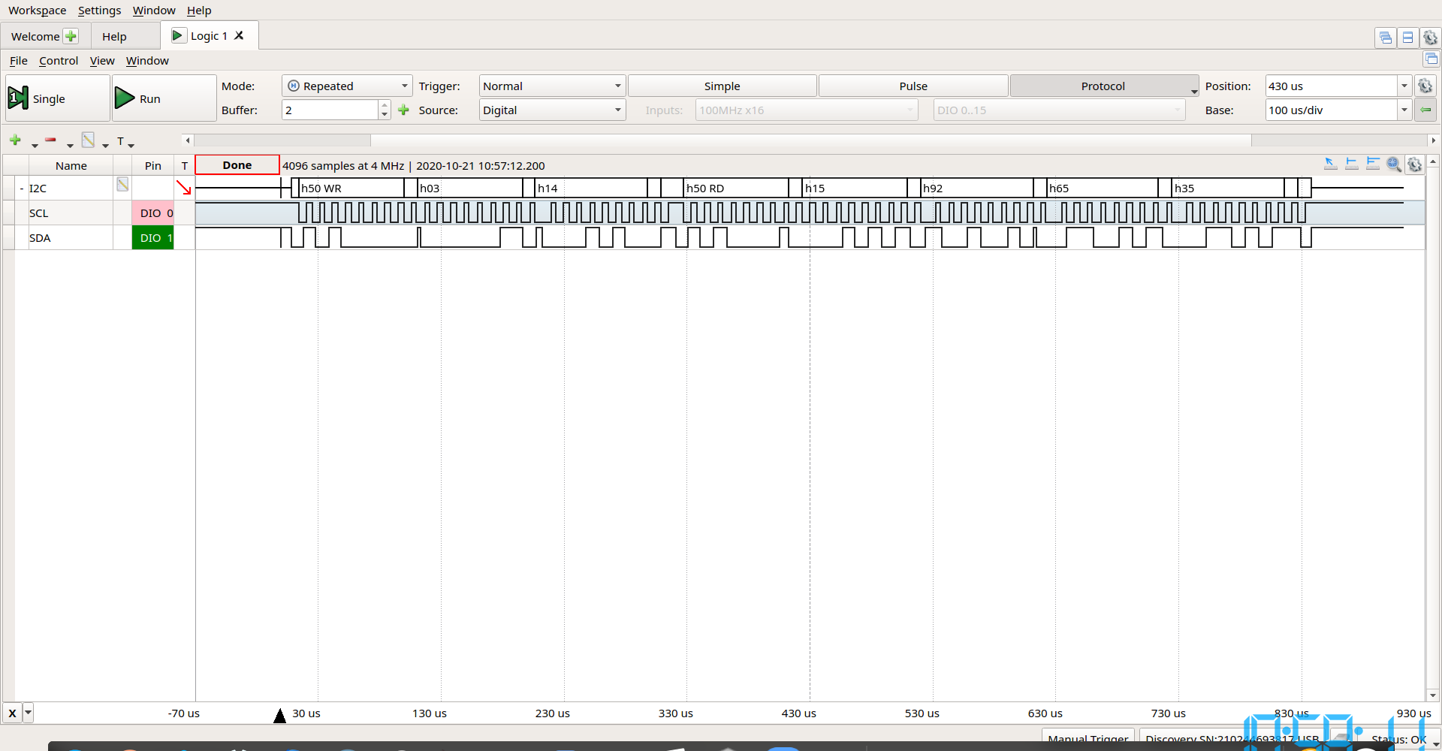

• The 7-bit slave address of the device which isn't present

0xfA

• The 7-bit slave address of the 24xx128 devive

0xA0

• The 8-bit data values which were written to the 24xx128

H15, h92, h65,h35

• The 14-bit memory address of the read from the 24xx128

H50